And I saw no temple in the city, for its temple is the Lord God the Almighty and the Lamb. And the city has no need of sun or moon to shine upon it, for the glory of God is its light, and its lamp is the Lamb. By its light shall the nations walk; and the kings of the earth shall bring their glory into it, and its gates shall never be shut by day – and there shall be no night there; they shall bring into it the glory and the honor of the nations. But nothing unclean shall enter it, nor any one who practices abomination or falsehood,
but only those who are written in the Lamb’s Book of Life.

Revelation 21:22-27
Click on this word. A box should appear. This box is for the particulars of the congregation, time, address, pastor, etc.
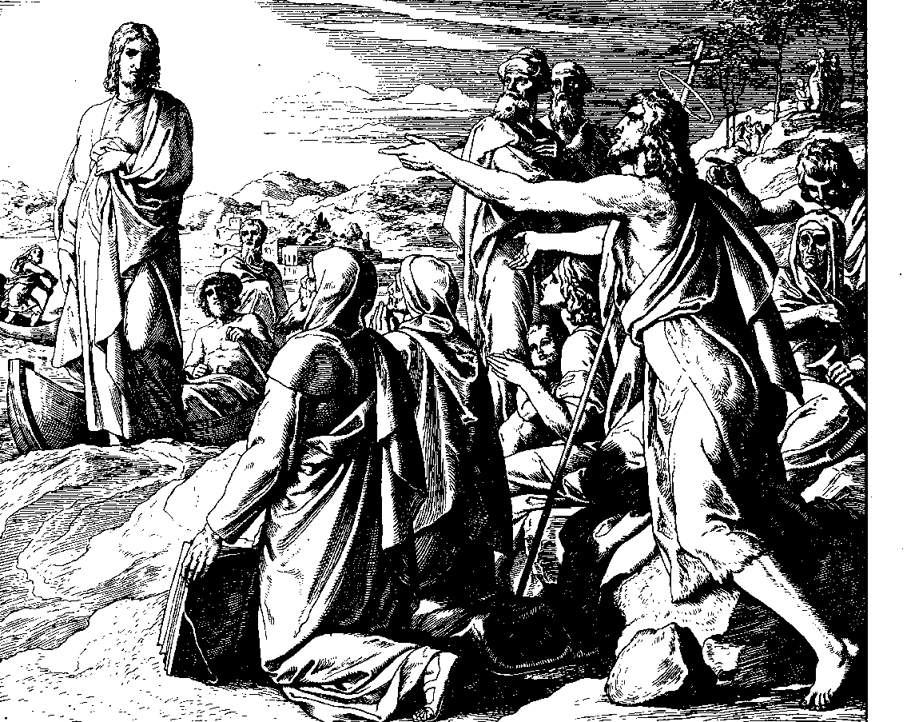
Since Christ willingly suffered, [note that] His torture and death is not just a plain, simple suffering. Rather, it is a great and high work, just as His actions in life were not merely simple works, but instead were at the same time a deep, severe suffering. This holy obedience of Christ should give us a powerful comfort against our disobedience against God’s commandment; for what the first Adam has spoiled and destroyed with his disobedience, behold, this other Adam, Christ, with His obedience has put right again. If indeed a faithful mother takes a bitter medicine in order to help her nursing baby, how should not the bitter death of Christ, which Isa. 49 likens to a mother’s love, benefit us for our soul’s health? Why, if a physician at times cures the illness of a [bodily] member by giving a medicine into the patient’s head [i.e., orally], how should not then the action and suffering of Christ, who is the Head of His believers, turn out for the best for us, His members? If someone accepts payment for your debt from someone other than you – just so it is completely paid – why should God the Lord not accept the entire, complete payment which Christ accomplished and provided for our sin? Behold, let this obedience of Christ comfort you at all times, especially in your last hour, when you will tremble before the judgment of God. And you will then say, Lord, I will not come into judgment, for you have set between me and You the obedience of Christ, my Lord.
An Explanation of the History of the Suffering and Death of our Lord Jesus Christ
by Johann Gerhard, pages 32-33
© 1998 by Elmer Hohle, Published by Repristination Press in 1999
Used with permission.
2nd Sunday after the Epiphany

20 January Anno Domini 2002

Behold, the Lamb of God, Who takes away the sin of the world! John 1:29
John Calls Jesus the Lamb of God by Julius Schnoor von Carolsfeld.
Permission to use this image is limited to personal and congregational use.
Courtesy of Wisconsin Evangelical Lutheran Synod - the World Mission Collection.

Scripture text is based on Revised Standard Version © 1946, 1952, 1971 Division of Education and Ministry of the National Council of the Churches of Christ in the United States of America.
All Rights Reserved.

This bulletin cover made available by www.scholia.net and is provided without cost.
And I saw no temple in the city, for its temple is the Lord God the Almighty and the Lamb. And the city has no need of sun or moon to shine upon it, for the glory of God is its light, and its lamp is the Lamb. By its light shall the nations walk; and the kings of the earth shall bring their glory into it, and its gates shall never be shut by day – and there shall be no night there; they shall bring into it the glory and the honor of the nations. But nothing unclean shall enter it, nor any one who practices abomination or falsehood,
but only those who are written in the Lamb’s Book of Life.

Revelation 21:22-27
Since Christ willingly suffered, [note that] His torture and death is not just a plain, simple suffering. Rather, it is a great and high work, just as His actions in life were not merely simple works, but instead were at the same time a deep, severe suffering. This holy obedience of Christ should give us a powerful comfort against our disobedience against God’s commandment; for what the first Adam has spoiled and destroyed with his disobedience, behold, this other Adam, Christ, with His obedience has put right again. If indeed a faithful mother takes a bitter medicine in order to help her nursing baby, how should not the bitter death of Christ, which Isa. 49 likens to a mother’s love, benefit us for our soul’s health? Why, if a physician at times cures the illness of a [bodily] member by giving a medicine into the patient’s head [i.e., orally], how should not then the action and suffering of Christ, who is the Head of His believers, turn out for the best for us, His members? If someone accepts payment for your debt from someone other than you – just so it is completely paid – why should God the Lord not accept the entire, complete payment which Christ accomplished and provided for our sin? Behold, let this obedience of Christ comfort you at all times, especially in your last hour, when you will tremble before the judgment of God. And you will then say, Lord, I will not come into judgment, for you have set between me and You the obedience of Christ, my Lord.

An Explanation of the History of the Suffering and Death of our Lord Jesus Christ
by Johann Gerhard
pages 32-33
© 1998 by Elmer Hohle, Published by Repristination Press in 1999.
Used with permission.
To place the graphic on this page:
Click on the graphic on the previous page and copy it.
Come down to this page. Click on the open space above and a graphic box should appear. Paste the graphic.

Change this frame and the box above by clicking the body of the text, deleting this text (not the box) and adding your particulars.
2nd Sunday after the Epiphany

20 January Anno Domini 2002
John Calls Jesus the Lamb of God by Julius Schnoor von Carolsfeld.
Permission to use this image is limited to personal and congregational use.
Courtesy of Wisconsin Evangelical Lutheran Synod - the World Mission Collection.

Scripture text is based on Revised Standard Version © 1946, 1952, 1971 Division of Education and Ministry of the National Council of the Churches of Christ in the United States of America.
All Rights Reserved.

This bulletin cover made available by www.scholia.net and is provided without cost.

Behold, the Lamb of God, Who takes away the sin of the world! John 1:29

